8) Basic calculator

CODE :-
//INTGERS//
#include <stdio.h>
#imclude<stdlib.h>

int main()
{
int num1;
int num2;
printf(“Enter the first number : ”);
scanf(“%d”, &num1);
printf(“Enter the second number : ”);
scanf(“%d”, &num2);
printf(“answer: %d”, num1 + num 2);

return 0;
}
output:-
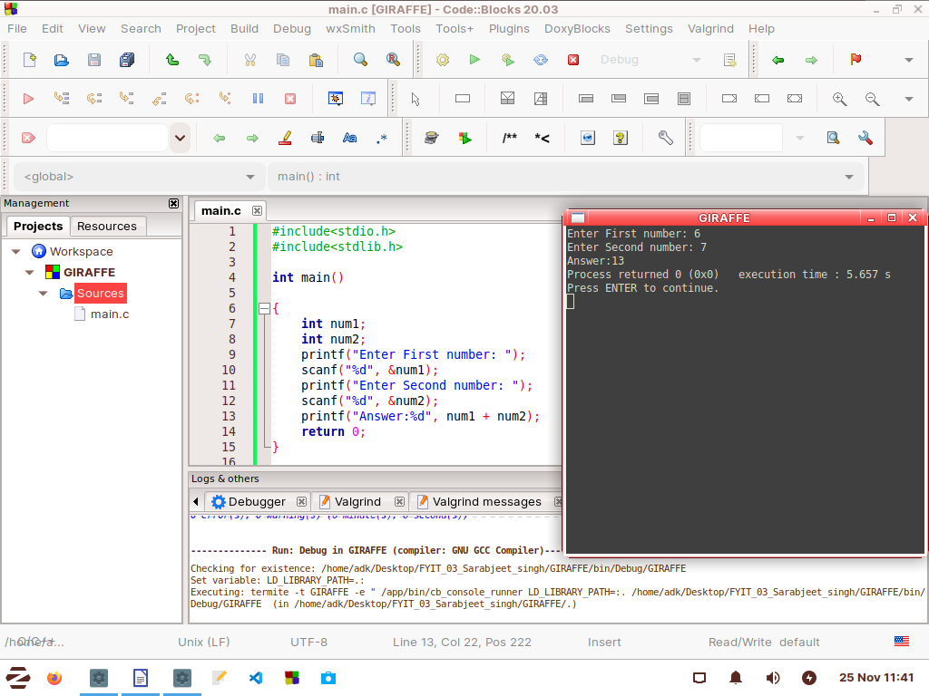

CODE :-
//float(double)//
#include <stdio.h>
#imclude<stdlib.h>

int main()
{
double num1;
double num2;
printf(“Enter the first number : ”);
scanf(“%lf”, &num1);
printf(“Enter the second number : ”);
scanf(“%lf”, &num2);
printf(“answer: %f”, num1 + num 2);

return 0;
}
output:-
